

Allegations Against Staff Policy

Allegations against staff, supply staff, volunteers or other adults

Updated by Director of Operations: July 2026.

1. Introduction and principles
There may be occasions when a pupil or adult makes an allegation against a member of staff, supply teacher, volunteer or other adult. There are two aspects to consider when an allegation is made:
- Looking after the welfare of the child and ensuring that the child is not at risk
- Investigating and supporting the person subject to the allegation.
When dealing with allegations, schools should:
- apply common sense and judgement;
- deal with allegations quickly, fairly and consistently; and
- provide effective protection for the child and support the person subject to the allegation.
All staff are expected to recognise the importance of confidentiality without compromising the need to refer safeguarding concerns.

NB: Keeping Children Safe in Education refers and sets out in specific detail the particular risks that may arise when employing supply teachers. Headteachers, DSLs and those involved in recruiting and managing supply teachers should make themselves familiar with this guidance.

2. Referring allegations to the Local Authority Designated Officer (LADO)
Each local authority appoints a LADO who is responsible for managing all child protection allegations made against staff and volunteers who work with children in their area.
The LADO must be consulted within 24 hours if there are concerns that a worker (member of staff, supply teacher or volunteer) has done any of the following inside or outside of school:
- Behaved in a way that has, or may have, harmed a child;
- Possibly committed a criminal offence in relation to a child; or
- Behaved towards a child in a way that indicates they may pose a risk of harm to children;
- Behaved or may have behaved in a way that did not involve children, but indicates they may not be suitable to work with children (this is known as a Transferable Risk).
How to make a LADO referral: Contact details for each school’s LADO, and a link to the LADO referral form, are on the front of the Q1E Child Protection and Safeguarding policy.
- Allegations about a staff member, volunteer or supply teacher should be referred to the Designated Safeguarding Lead (DSL) and Head. The DSL/Head will refer to the LADO.
- Allegations about a Head/Executive Head should be referred to the CEO and the Trust’s safeguarding lead, or direct to the LADO.
- Refer allegations about the CEO to the Chair of the Trust Board and the Trust’s safeguarding lead, or direct to the LADO.

The person referring the allegation to the LADO should discuss the nature, content and context of the allegation with the LADO, agree the course of action to be taken, and normally assign a case manager within the school. The case manager’s role is to:
- manage and minimise the stress caused by the allegation
- inform the individual as soon as possible, explaining the likely course of action, guided by the LADO, and the police where necessary
- advise the individual to contact their trade union representative, or a colleague, for support
- appoint a named representative to keep the person informed about the progress of the case
- provide access to counselling or medical advice where appropriate, and,
- not prevent social contact with work colleagues and friends, when staff are suspended, unless there is evidence to suggest this may prejudice the gathering of evidence.
3. Other referrals that may need to be made
- Immediate referrals to children’s social care: Where the school identifies that a child has been harmed, or there may be an immediate risk of harm to a child, they should contact children’s social care immediately. How to make a referral to social care: Details for children’s social care in your area can be found on the front of the Q1E Child Protection and Safeguarding Policy.
- Referrals to the police: If the situation is a safeguarding emergency, the school should contact the police immediately. If there is an allegation about someone who no longer works at the school, contact the police rather than the LADO. How to contact police: In an emergency, always call 999. In a non-emergency situation, call 101 or report online: www.police.uk/pu/contact-the-police/report-a-crime-incident/.
- Referrals to the Disclosure and Barring Service (DBS): Employers are legally required to make a referral to the DBS where they consider an individual has engaged in conduct that harmed (or is likely to harm) a child; or if a person otherwise poses a risk of harm to a child. If the allegation is substantiated. but the person has left (i.e. the person is dismissed, resigns, or the school/trust ceases to use the person’s services) then the school still has a legal duty to make a referral to the DBS, so that they can consider whether the person is required to be included on the barred lists. How to make a DBS referral: www.gov.uk/guidance/making-barring-referrals-to-the-dbs
- Referrals to the Teaching Regulation Agency (TRA): For teaching staff, the school must also consider whether to refer to the TRA, to consider prohibiting them from teaching. How to make a TRA referral: www.gov.uk/government/collections/teacher-misconduct#referrals
- Referrals to Ofsted: Concerns about Early Years staff must also be referred to Ofsted.

4. ‘Low level’ concerns
You should always report even ‘low-level’ concerns about a member of staff, supply staff, volunteer or contractor, so that any potential patterns of inappropriate behaviour can be identified. Low-level concerns could include, but are not limited to:
- being over friendly with children;
- having favourites;
- taking photographs of children on a personal mobile phone;
- engaging with a child on a one-to-one basis in a secluded area or behind a closed door;
- using inappropriate sexualised, intimidating or offensive language.
The Staff Code of Conduct sets out further details of what conduct is and is not acceptable.
How to report a low level concern: All low-level concerns should be reported to the DSL or the head. If they are reported to the DSL, the DSL should inform the head in a timely fashion according to the nature of the concern. The head is the ultimate decision maker on the course of action to be taken, although he/she may wish to consult with the DSL. Low-level concerns about supply staff and contractors will be notified to their employers. If there is any doubt as to whether something is a low-level concern or in fact meets the harm threshold, the school should consult with their LADO.

5. Unsubstantiated allegations
If an allegation is determined to be unsubstantiated, unfounded, false or malicious, the LADO and the case manager should consider whether the child and/or the person who has made the allegation is in need of help or may have been abused by someone else and this is a cry for help. In such circumstances, a referral to children’s social care may be appropriate.
If a report is shown to be deliberately invented or malicious, the school should consider whether any disciplinary action is appropriate against the individual who made it, consulting HR for advice.

6. Whistleblowing

Concerns about the school/trust can be raised through the process set out in the Q1E Whistleblowing Policy. Whistleblowing is the act of telling the authorities or the public that the organisation you work for is doing something immoral or illegal, and which is in the public interest.

Appendix A: Managing allegations against staff: Flow Chart
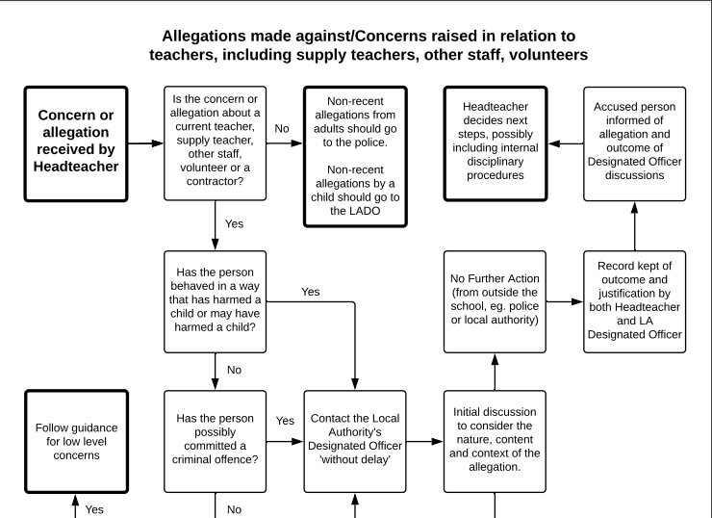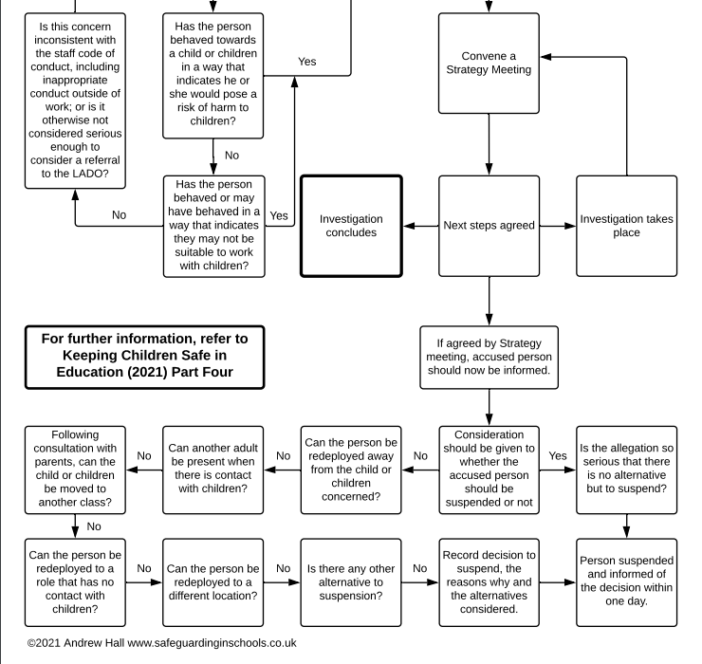
Appendix B: Managing low level concerns: Flow Chart

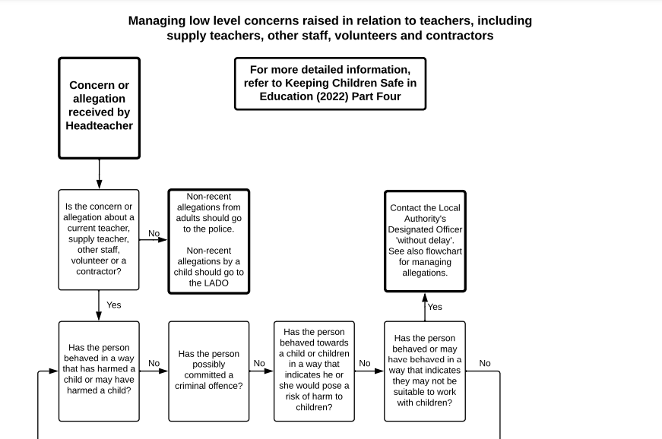
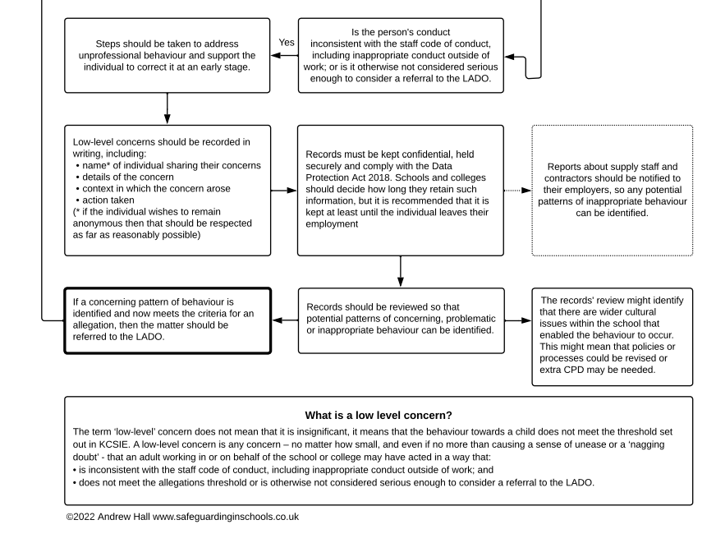

Appendix C: LADO referral / contact forms

Please follow the links below for the latest contact details and forms (where applicable) for the appropriate borough for the school where the member of staff is based.

LADO contact form for Wandsworth borough
(Belleville Primary School, Belleville Wix Academy and The Alton School)
https://www.wandsworth.gov.uk/health-and-social-care/children-and-families/lado/

LADO contact form for Bromley borough
(Churchfields Primary School)
https://www.bromleysafeguarding.org/articles.php?id=604

LADO referral form for Hammersmith & Fulham borough
(Thomas’s Academy/ New King’s Road School)
https://www.rbkc.gov.uk/lscp/sites/default/files/atoms/files/LADO%20referral%20form.pdf

