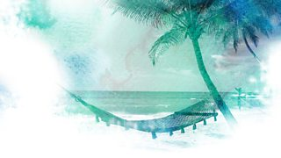
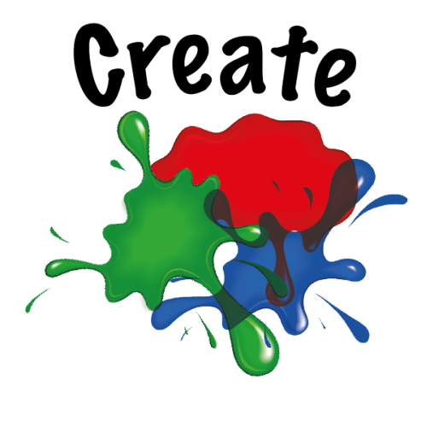

Create your ‘Desert Island Discs’
Challenge | 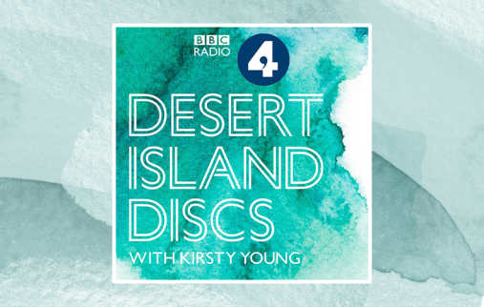  Imagine you were on a desert island, on your own  You are allowed to take:  - 6 music tracks/songs *  - A luxury item  - A book of your choice  The music is the real point…  It usually reminds the person of something or someone or that they would want to listen to over and over again. There are over 2000 radio episodes of this show where celebrities talk about their choices.  You can listen here to get the idea…
Resources | - music  - a guest  - a way to record your conversation (optional)
Extra | You could  - talk about your own desert island discs to someone  - interview a family member or friend and find out theirs.  - record it and make it as a radio show.  - share the choices with us! (with your guest’s permission of course)

We’d love to see all the great learning your children are doing at home. A way to share this with our community is to take a photo of your child's work and tag us at q1ehomelearning - this is on either Twitter or Instagram

